**SOFTWARE DEVELOPMENT DOCUMENT**

**FOR**

**GYM CUSTOMER – HEALTH CLUB**

**Assignment: DSED-04 Group Assessment**

**Course: Level 6 Diploma in Software Development**

**Submitted on**June 13, 2021

|  |  |
| --- | --- |
| **Submitted By:** Danish Bhala Paramjeet Kaur Amritpal Singh Parabhjot Singh | **Submitted to:** Bikash Pokhrel Tutor ATC Vision College  East Tamaki, Auckland |

1. **Introduction:**

This project is group project and is a part of our assessment for New Zealand Diploma in Software Development Diploma Level 6. This application is a health club application with that has ability to manage customers.

1. **Project Features:**
2. Add new customer
3. Update customer details
4. Delete customer details.
5. Simple intuitive interface
6. **Project Time Line**

|  |  |  |
| --- | --- | --- |
| SN | Item | Time |
| 1. | Project discussion and finalize | 5 hours |
| 2. | Wireframe design | 1. hours |
| 3. | Final Design | 2 hours |
| 4. | Meetings on Scrum sprints | 15 minutes everyday until project finished |
| 5. | Coding | 4 hours |
| 6. | Questions answers | 2 hours |
| 7. | Software documentation | 1 hour |
| 9. | Testing document | 1. hour |

1. **Loading Screen**

Wireframe:

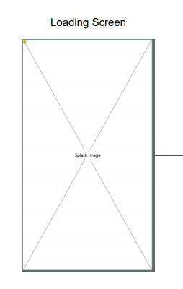

Final Design:



1. **Customer List Screen**

Wireframe:

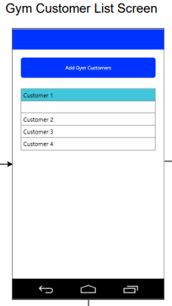

Final Design:

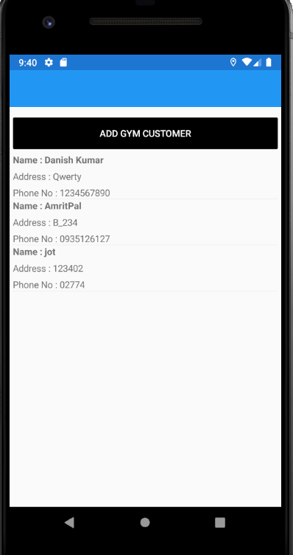

1. **Register New Customer Screen**

Wireframe:

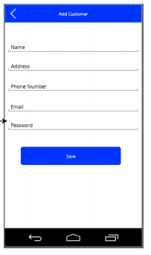

Final Design:

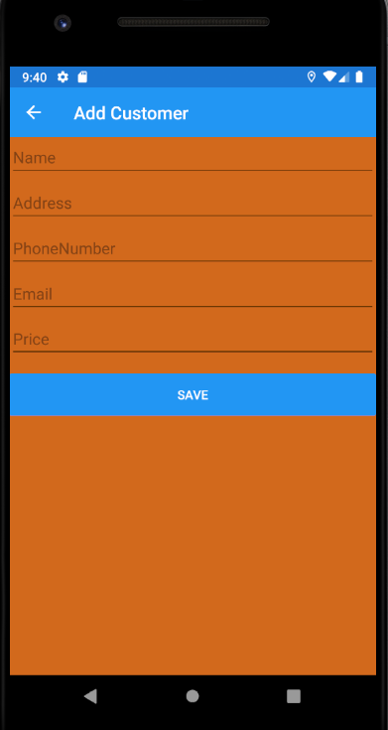

1. **Update Gym Customer Screen**

Wireframe:

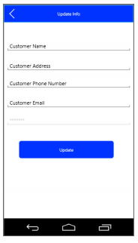

Final Design:

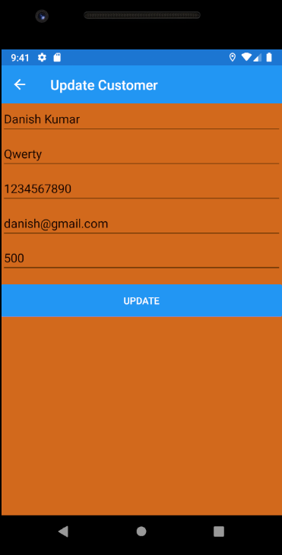

1. **Delete Gym Customer Screen**

Wireframe:

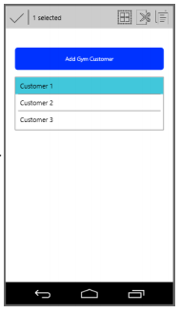

Final Design:

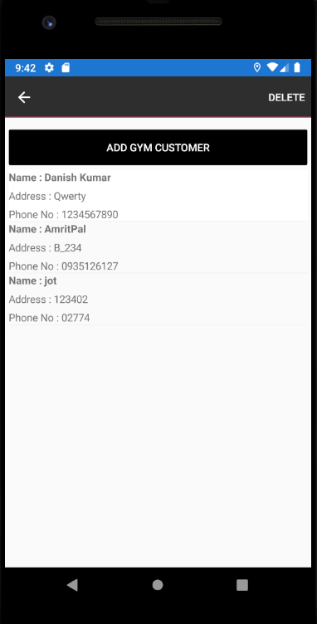

1. **Wireframe designs and their flow**

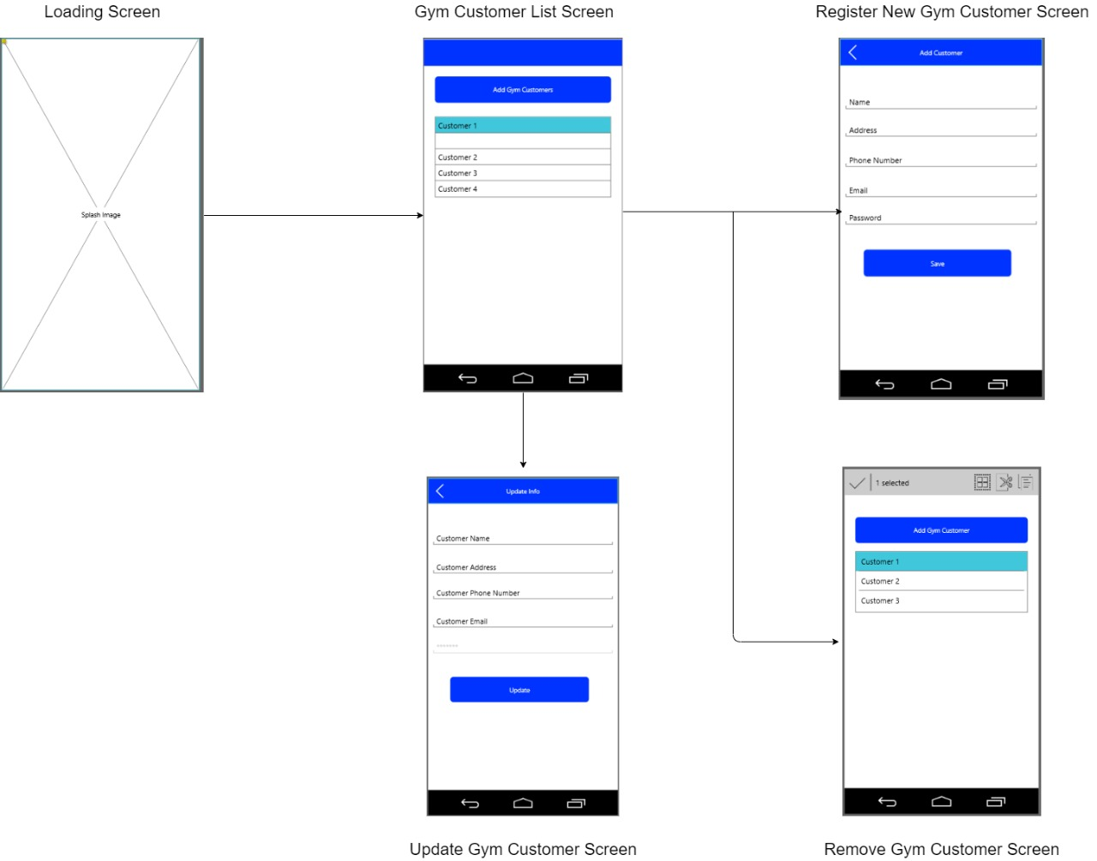

1. **Emulator Specification:**

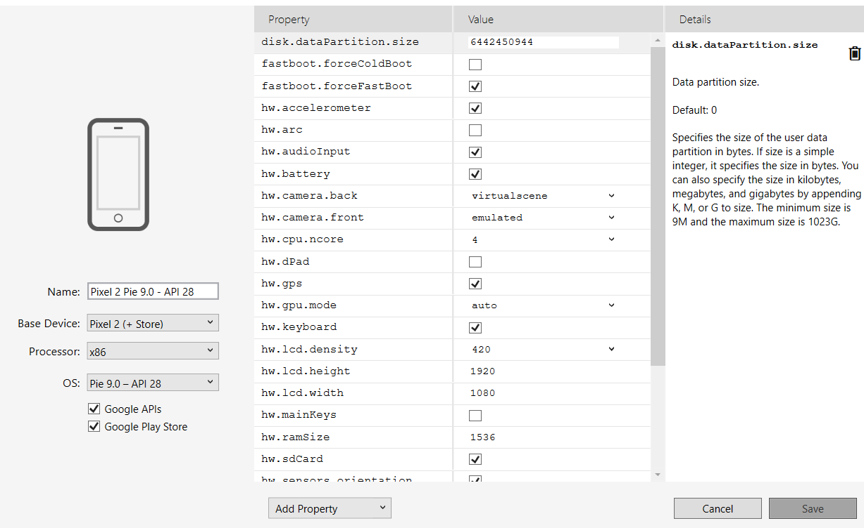

1. **Coding**

**Customer.cs**

using SQLite;

using System;

using System.Collections.Generic;

using System.Text;

namespace HealthClub.Model

{

public class Customer

{

[PrimaryKey, AutoIncrement]

public int ID { get; set; }

public string Name { get; set; }

public string Address { get; set; }

public string PhoneNumber { get; set; }

public string Email { get; set; }

public string Fee { get; set; }

}

}

**Mainpage.xaml**

<?xml version="1.0" encoding="utf-8" ?>

<ContentPage xmlns="http://xamarin.com/schemas/2014/forms"

xmlns:x="http://schemas.microsoft.com/winfx/2009/xaml"

x:Class="HealthClub.MainPage">

<ContentPage.Content>

<StackLayout Padding="5">

<Button x:Name="AddCustomer" Text="Add Gym Customer" Clicked="AddCustomer_Clicked"

HorizontalOptions="FillAndExpand" BackgroundColor="Black" TextColor="White" Margin="0,10,0,0"/>

<ListView x:Name="CustomerList" HasUnevenRows="True" ItemTapped="EditCustomer">

<ListView.ItemTemplate>

<DataTemplate>

<ViewCell>

<ViewCell.ContextActions>

<MenuItem Text="Delete" Clicked="DeleteCustomer" IsDestructive="True" CommandParameter="{Binding .}"/>

</ViewCell.ContextActions>

<StackLayout>

<Label Text="{Binding Name,StringFormat='Name : {0:F0}'}" FontSize="Small" FontAttributes="Bold"/>

<Label Text="{Binding Address,StringFormat='Address : {0:F0}'}" FontSize="Small" FontAttributes="None"/>

<Label Text="{Binding PhoneNumber,StringFormat='Phone No : {0:F0}'}" FontSize="Small" FontAttributes="None"/>

</StackLayout>

</ViewCell>

</DataTemplate>

</ListView.ItemTemplate>

</ListView>

</StackLayout>

</ContentPage.Content>

</ContentPage>